Department of Computing

COURSE: SOFTWARE CONFIGURATION MANAGEMENT |  |  | MARKS:  /10
COURSE CODE: BCS 3293 |  |  | MARKS:  /10
SEMESTER:2 |  |  | MARKS:  /10
TOPIC : Chapter Three: Environment Configuration |  |  | MARKS:  /10
TYPE OF ASSESSMENT: ASSIGNMENT |  |  | MARKS:  /10
ASSESSMENT NO:3 |  |  | MARKS:  /10
TIME / DEADLINE: 1 WEEK |  |  | MARKS:  /10
STUDENT NAME: Hamed SIGNATURE:

STUDENT ID: 15126 SECTION:
FEEDBACK(If Any):

LECTURER NAME: Ms.AKHILA.K.R SIGNATURE:

Department of Computing

COURSE: SOFTWARE CONFIGURATION MANAGEMENT |  |  | MARKS:  /10
COURSE CODE: BCS 3293 |  |  | MARKS:  /10
SEMESTER:2 |  |  | MARKS:  /10
TOPIC : Chapter Three: Environment Configuration |  |  | MARKS:  /10
TYPE OF ASSESSMENT: ASSIGNMENT |  |  | MARKS:  /10
ASSESSMENT NO:3 |  |  | MARKS:  /10
TIME / DEADLINE: 1 WEEK |  |  | MARKS:  /10
STUDENT NAME: Lubna SIGNATURE:

STUDENT ID:15184 SECTION:
FEEDBACK(If Any):

LECTURER NAME: Ms.AKHILA.K.R SIGNATURE:

Department of Computing

COURSE: SOFTWARE CONFIGURATION MANAGEMENT |  |  | MARKS:  /10
COURSE CODE: BCS 3293 |  |  | MARKS:  /10
SEMESTER:2 |  |  | MARKS:  /10
TOPIC : Chapter Three: Environment Configuration |  |  | MARKS:  /10
TYPE OF ASSESSMENT: ASSIGNMENT |  |  | MARKS:  /10
ASSESSMENT NO:3 |  |  | MARKS:  /10
TIME / DEADLINE: 1 WEEK |  |  | MARKS:  /10
STUDENT NAME: Aisha SIGNATURE:

STUDENT ID: 15410 SECTION:
FEEDBACK(If Any):

LECTURER NAME: Ms.AKHILA.K.R SIGNATURE:

INSTRUCTIONS:
- Based on the groups assigned to you, you are required to choose one Group Leader.
- You will be given one Software Configuration Management name per group.
- Group leader should separate the task between all the team members.
- Group leader must record task and minutes meeting.
- You are required to prepare a slides presentation on the following:

- Why is Environment Configuration Important?
- Supporting Code Promotion.
- Managing the Configuration.
- Practical Approaches to establishing a CMDB.
- Change Control depends on Environment Configuration.
- Minimize the Number of Controls Required.
- Managing Environments.
- The future of Environment Configuration.
- You are required to do a presentation within 15 minutes. If your presentation lasts longer, you will be stopped and the remaining parts of your presentation will not be counted. So, please rehearse your presentation to make sure it lasts only 12 minutes.

- Each group will be called up for presentation AT RANDOM.
- Every group member must present their parts. Presentation will be in English.
- After your presentation, there would be a 3 minutes question and answer session.
- Marks will be given based on your presentation.

GOOD LUCK!

- Why is Environment Configuration Important?
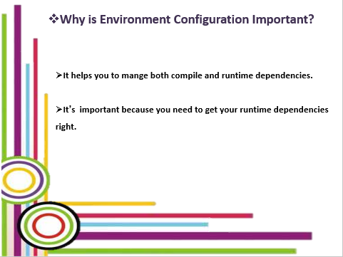

- Supporting Code Promotion.
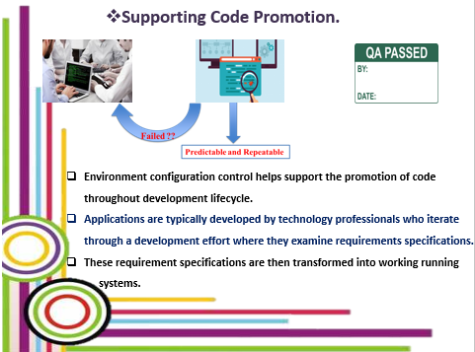

- Managing the Configuration.

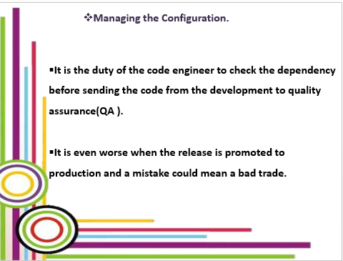
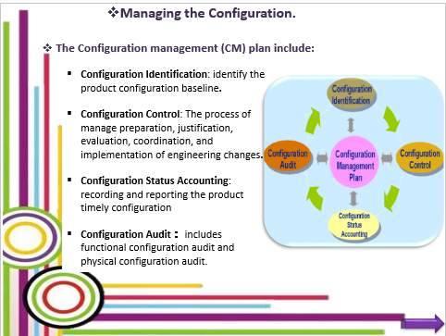

- Practical Approaches to establishing a CMDB.
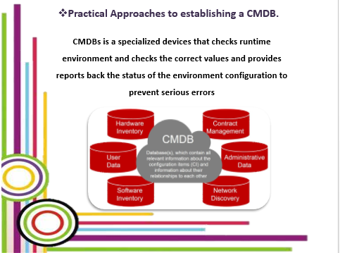
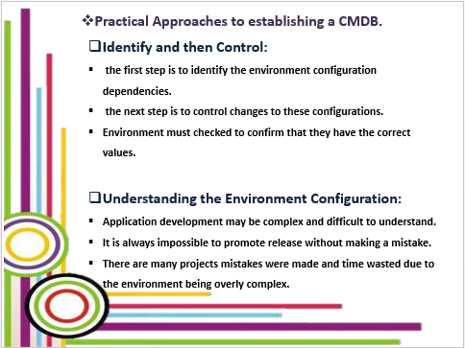

- Change Control depends on Environment Configuration.

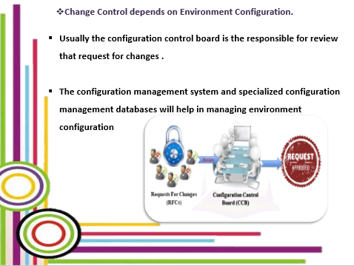

- Minimize the Number of Controls Required.
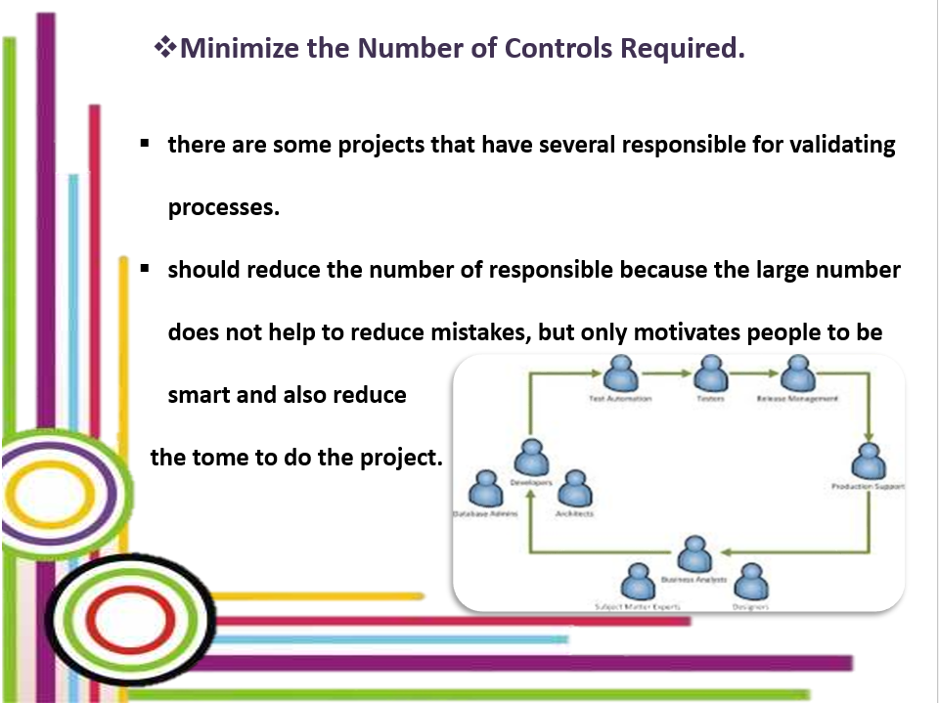

- Managing Environments.
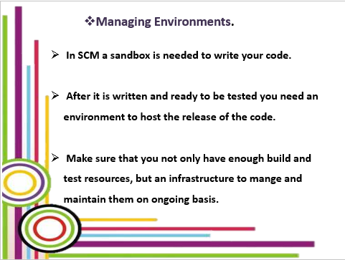

- The future of Environment Configuration.

